**H.H.THE RAJAH’S COLLEGE**

**PUDUKKOTTAI– 622001**

**DEPARTMENT OF MATHS**

**NAAN MUDHALVAN – SMART BRIDGE PROJECT**

**PROJECT TITLE**

**A CRM APPLICATION FOR SCHOOLS &COLLEGES**

**SUBMITTED BY**

TEAM LEADER : AYYAPPAN K (20ME 2206)

TEAM MEMBER 1 : PRAVEENRAJ P (20ME 2227)

TEAM MEMBER 2 : PURUSHOTHAMAN K (20ME 2228)

TEAM MEMBER 3 : TAMILVEL T (20ME 2235)

**Faculty Mentor**

**Dr. R. Muthuraj**

Assistant Professor of Mathematics

H. H. The Rajah’s College, Pudukkottai – 622 001.

**INDEX**

|  |  |  |  |  |
| --- | --- | --- | --- | --- |
| **S.NO** | **CONTENT** | | | **PAGE NO** |
| **1** | **Introduction** | | |  |
| **1.1** | | Overview | 3 |
| **1.2** | | Purpose | 3 |
| **2** | **Problem Definition & Design Thinking** | | |  |
| **2.1** | | Empathy Map | 4 |
| **2.2** | | Ideation & Brainstorming Map | 5 |
| **3** | **Result** | | |  |
| **3.1** | Data Model | | 5 |
| **3.2** | Activity & Screenshot | | 6 |
| **4** | **Trailhead Profile Public URL** | | | 10 |
| **5** | **Advantages & Disadvantages** | | | 10 |
| **6** | **Applications** | | | 12 |
| **7** | **Conclusion** | | | 14 |
| **8** | **Future Scope** | | | 14 |
|  | | | | |

**1.INTRODUCTION**

**1.1 Overview**

A CRM (Customer Relationship Management) application is a software solution designed to help businesses manage their interactions with customers more effectively. The primary purpose of a CRM system is to streamline and optimize customer relationships, ultimately resulting in increased customer satisfaction, loyalty, and sales.

In the context of schools and colleges, a CRM application can be used to manage interactions with students, parents, and other stakeholders. The application can be used to track student progress, manage enrollment and course scheduling, maintain academic records, and manage financial transactions.

The use of a CRM application in the education sector can bring significant benefits, such as improved efficiency, better communication, increased student engagement, and more personalized learning experiences. It can also help institutions make data-driven decisions and optimize their operations.

Overall, a CRM application is a powerful tool that can help businesses and educational institutions manage and optimize customer or student relationships. By providing a centralized platform for tracking and analyzing data, organizations can improve their operations and achieve their goals more effectively.

**1.2 Purpose**

A CRM (Customer Relationship Management) application for schools and colleges can help them manage their interactions with various stakeholders such as students, parents, alumni, faculty, staff, and other partners.

**2.Problem Definition & Design Thinking**

2.1 EMPATHY MAP

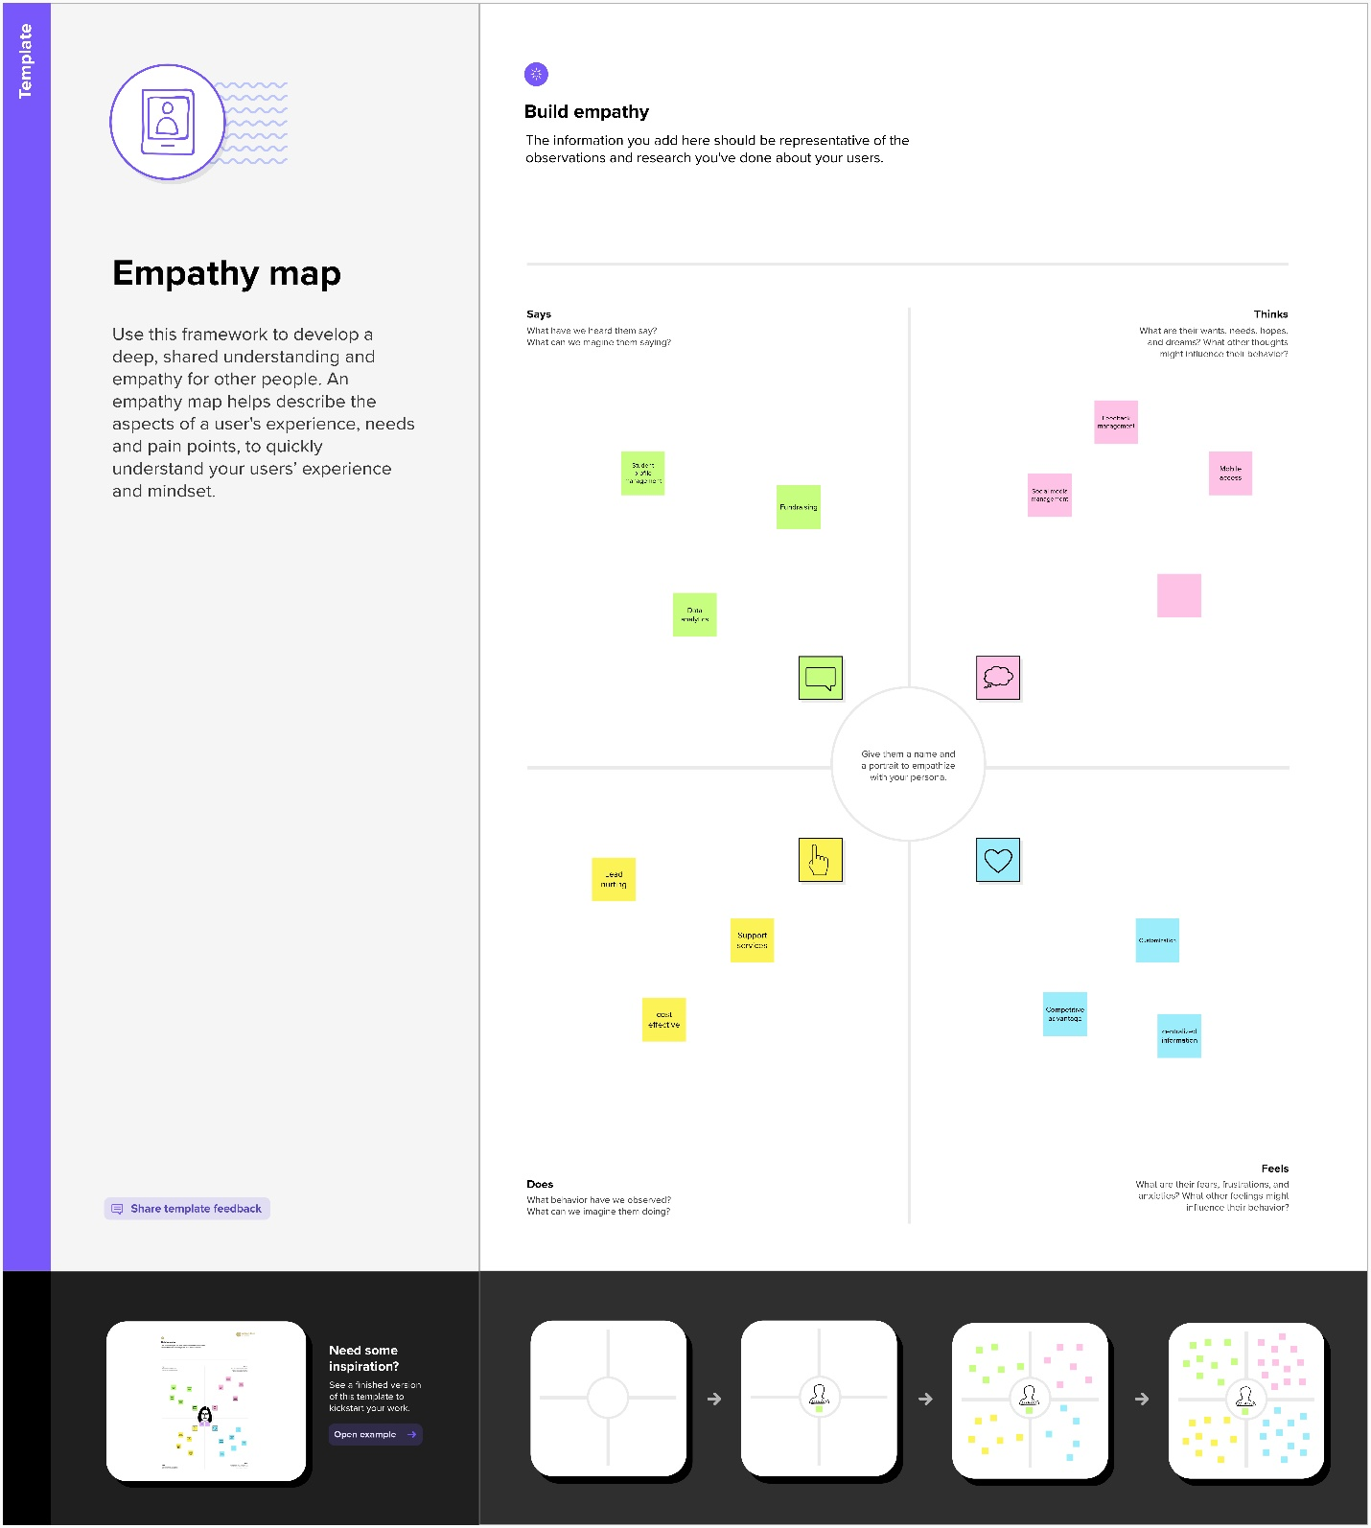

2.2 IDEATION & BRAINSTORMING MAP

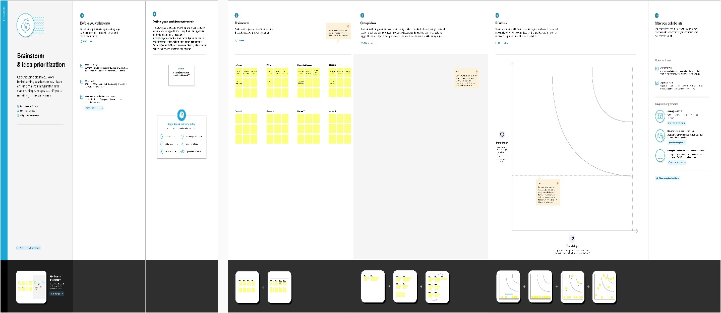

**RESULT**

3.1 Data Model

|  |  |
| --- | --- |
| **Object name** | **Fields in the object** |
| School Object | |  |  | | --- | --- | | Field label | Data type | | Address | Text Area | | District | Text Area | | State | Text Area | | School Websites | Text Area | | Phone number | Phone | | Number of students | Roll-up summary | |
| Student Object | |  |  | | --- | --- | | Field label | Data type | | Phone Number | Phone | | School | Master-detail relationship | | Results | Picklist | | Class | Number | |
| Parent Object | |  |  | | --- | --- | | Field label | Data type | | Parent Address | Text Area | | Parent Number | Phone | |

**3.2 Activity & Screenshot**

**School Objects**

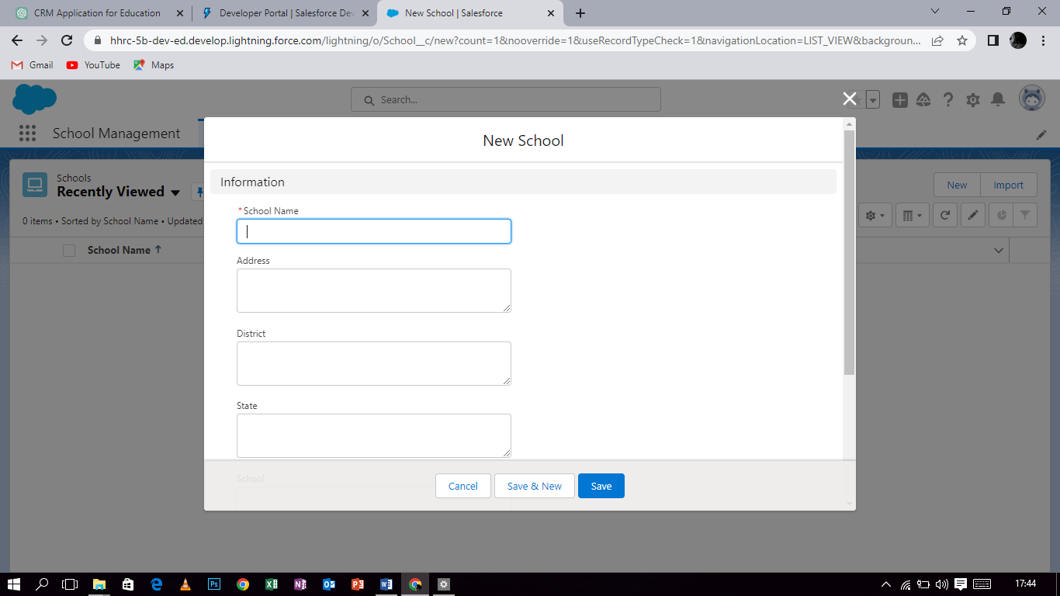

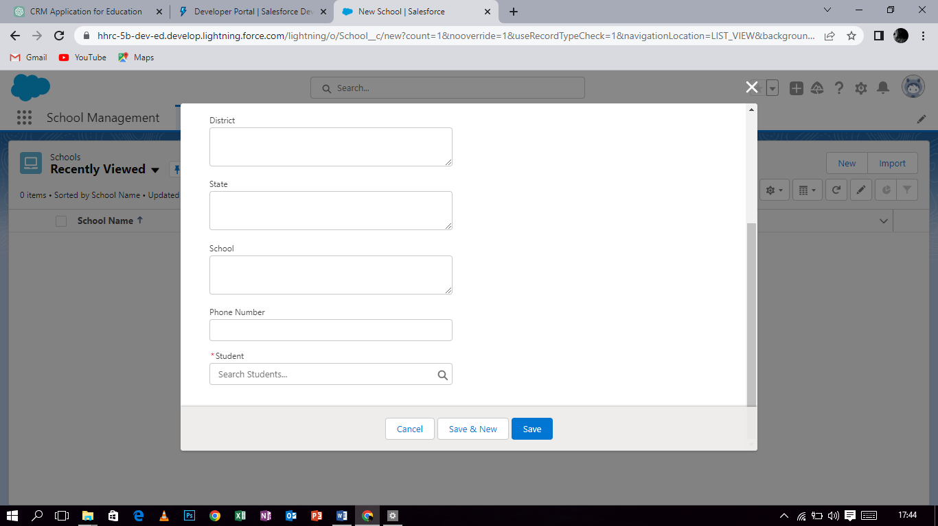

This object would likely contain information such as the school's name, location, contact information, and other relevant details.

Additionally, the school object could also have relationships with other objects within the CRM system. For example, it may be related to student objects, teacher objects, course objects, and more. This would allow for easy management of all aspects of the school's operations within the CRM system.

**Student Objects**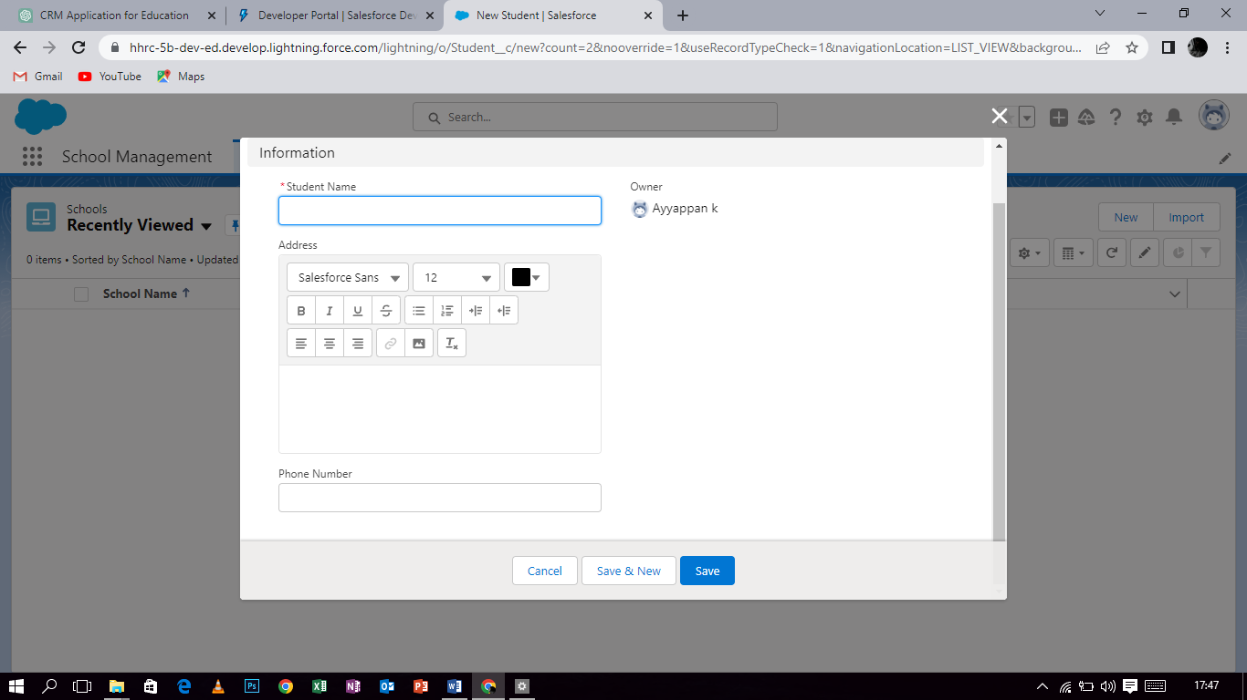

This object would typically contain information about the student, such as their name, contact information, enrollment status, academic record, attendance record, and any other relevant data.

The student object may also be linked to other objects within the CRM system, such as a "course" object, which would represent the courses the student is enrolled in, or a "teacher" object, which would represent the instructors responsible for teaching those courses. Additionally, the student object could be used to track interactions between the institution and the student, such as communications and engagement initiatives.

Overall, the student object in a CRM application for schools and colleges serves as a central hub for managing and tracking student data, interactions, and progress throughout their time at the institution.

**Parent Objects**

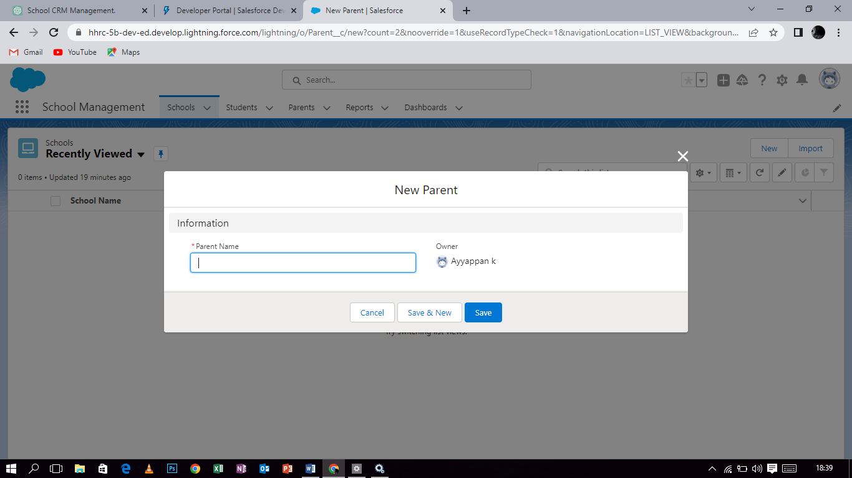 The parent object would likely be a "Student" object. This is because the student is the primary entity that the CRM application would be designed to manage, and parents are typically associated with their children's accounts in such a system.

The Student object would contain information about each student, such as their name, contact information, academic history, and any other relevant data. The Parent object would then be related to the Student object, likely through a one-to-many relationship, as each student may have multiple parents or guardians associated with their account.

The Parent object would contain information about each parent or guardian, such as their name, contact information, and relationship to the student. This information would be used to facilitate communication between the school orcollege and the student's family, as well as to keep track of important information related to the student's academic progress and overall well-being.

**4.Trailhead Profile Public URL**

Team Lead - <https://trailblazer.me/id/ayyappank>

Team Member 1- <https://trailblazer.me/id/praveenrajp>

Team Member 2-<https://trailblazer.me/id/purushothaman12>

Team Member 3-<https://trailblazer.me/id/ttv3l>

**5.Advantages & Disadvantages**

A CRM (Customer Relationship Management) application can provide several advantages for schools and colleges, including:

1. Improved Communication: A CRM application can help schools and colleges to communicate more effectively with students, parents, faculty, and staff. It can automate and streamline communication processes, such as sending reminders for upcoming events, sending newsletters, or sharing important announcements.
2. Better Student Engagement: A CRM application can help schools and colleges to improve student engagement by providing personalized communication, recommendations, and support. It can track students' progress and interactions, and provide insights into their needs, preferences, and challenges.
3. Increased Efficiency: A CRM application can automate many administrative tasks, such as student enrollment, tracking attendance, and managing schedules. It can also provide real-time data and analytics to help schools and colleges to make informed decisions and optimize their resources.
4. Enhanced Collaboration: A CRM application can facilitate collaboration between different departments, teachers, and staff. It can enable sharing of information, knowledge, and resources, and improve teamwork and productivity.
5. Improved Accountability: A CRM application can help schools and colleges to maintain accurate records and documentation, and ensure compliance with regulations and standards. It can also provide transparency and accountability in decision-making and performance evaluation.

Overall, a CRM application can help schools and colleges to provide a better experience for their students, faculty, and staff, and achieve their goals more efficiently and effectively.

**Disadvantages**

While there are many advantages to using a CRM application for schools and colleges, there are also some potential disadvantages, including:

1. Implementation Costs: The initial cost of implementing a CRM application can be high, as it may require significant investment in hardware, software, and staff training. This may be a barrier for some schools and colleges, particularly those with limited budgets.
2. Data Security Concerns: A CRM application requires the storage and management of sensitive data, including student and staff personal information, academic records, and financial data. This can create data security concerns, particularly if the system is not properly secured or maintained.
3. Integration Issues: A CRM application may need to integrate with other existing systems, such as student information systems, learning management systems, or financial management systems. Integration can be complex and time-consuming, and may require additional resources or technical expertise.
4. User Adoption: A CRM application may be met with resistance from staff, students, or parents who are not familiar with the system or prefer traditional communication methods. This can lead to low user adoption rates, and limit the potential benefits of the system.
5. Maintenance and Upkeep: A CRM application requires ongoing maintenance and updates to ensure optimal performance and security. This can be time-consuming and costly, particularly for smaller schools or colleges with limited IT resources.

Overall, schools and colleges should carefully consider the potential advantages and disadvantages of a CRM application before implementing one. A thorough needs assessment, cost-benefit analysis, and risk assessment can help to determine if a CRM application is the right choice for the institution.

**6.Applications**

A CRM (Customer Relationship Management) application can have several applications for schools and colleges, including:

1. Student Recruitment and Enrollment: A CRM application can help schools and colleges to manage the student recruitment and enrollment process, from lead generation to application submission to enrollment. It can track prospective students' interactions with the institution, personalize communication and marketing efforts, and automate administrative tasks.
2. Student Success and Retention: A CRM application can help schools and colleges to support student success and retention by providing personalized communication, resources, and support. It can track students' progress and engagement, identify at-risk students, and provide targeted interventions to improve retention and graduation rates.
3. Fundraising and Donor Management: A CRM application can help schools and colleges to manage their fundraising and donor management efforts. It can track donor interactions, manage fundraising campaigns, and provide insights into donor preferences and behavior.
4. Alumni Relations: A CRM application can help schools and colleges to maintain and strengthen relationships with their alumni. It can track alumni engagement, provide opportunities for networking and mentorship, and facilitate fundraising and giving.
5. Faculty and Staff Management: A CRM application can help schools and colleges to manage faculty and staff relationships and interactions. It can track faculty and staff engagement, automate administrative tasks such as scheduling and leave requests, and provide insights into performance and productivity.

Overall, a CRM application can provide a centralized system for managing and improving relationships with students, faculty, staff, donors, and alumni, and support the overall mission of the institution.

**7.Conclusion**

In conclusion, a CRM (Customer Relationship Management) application can offer several benefits for schools and colleges, including improved communication, better student engagement, increased efficiency, enhanced collaboration, and improved accountability. It can be applied in a variety of areas, such as student recruitment and enrollment, student success and retention, fundraising and donor management, alumni relations, and faculty and staff management.

However, there are also potential disadvantages to consider, such as implementation costs, data security concerns, integration issues, user adoption, and maintenance and upkeep. Therefore, schools and colleges should carefully assess their needs, resources, and risks before implementing a CRM application.

Overall, a well-implemented CRM application can provide a valuable tool for schools and colleges to manage and improve relationships with their stakeholders, achieve their goals more efficiently and effectively, and ultimately provide a better experience for their students, faculty, and staff.

**8.Future Scope**

The future scope of CRM (Customer Relationship Management) applications for schools and colleges is promising, as technology continues to evolve and institutions seek more efficient and effective ways to manage their relationships with stakeholders.

Some potential future developments in CRM applications for schools and colleges may include:

1. Artificial Intelligence: CRM applications may incorporate artificial intelligence (AI) to provide more personalized and predictive communication, support, and interventions for students, faculty, and staff. AI can help to automate routine tasks, provide real-time insights and recommendations, and improve decision-making.
2. Virtual and Augmented Reality: CRM applications may incorporate virtual and augmented reality (VR/AR) to provide immersive experiences for students, faculty, and staff. This can enhance learning and engagement, provide virtual tours and simulations, and facilitate remote communication and collaboration.
3. Internet of Things: CRM applications may incorporate the Internet of Things (IoT) to provide real-time data and analytics on various aspects of the institution, such as student behavior, environmental conditions, or resource usage. This can help to optimize operations and resources, improve sustainability, and provide insights for strategic planning.
4. Mobile and Cloud-Based Access: CRM applications may become more mobile and cloud-based, allowing stakeholders to access the system from anywhere, at any time, and on any device. This can provide greater flexibility and convenience, support remote learning and work, and improve data accessibility and security.
5. Blockchain Technology: CRM applications may incorporate blockchain technology to provide secure and transparent data management and sharing, particularly for sensitive data such as student records or financial transactions. This can improve data security, privacy, and trust, and reduce administrative overhead.

Overall, the future scope of CRM applications for schools and colleges is exciting, as it offers opportunities for institutions to enhance their relationships with stakeholders, improve their operations, and achieve their goals more effectively and efficiently.

Top of Form

Top of Form